**Biology Today – BIO112**

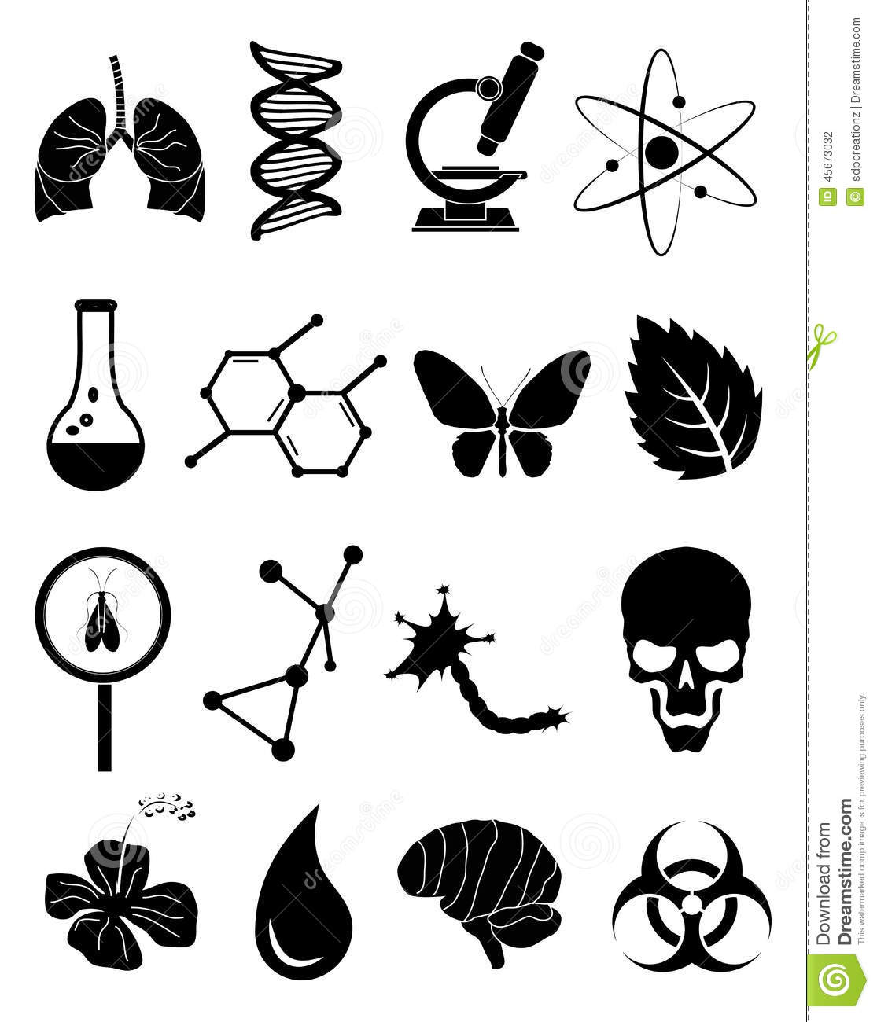

**Course Number:** BIO112_02

**Meeting Times, Place:** MR 12:30pm-1:45pm, CSB 023

**Instructor:** Kara Loeb Belinsky, PhD

**Email:** belinskk@newpaltz.edu

**Office, Phone:** CSB 218, x3748 (please e-mail for faster response)

**Office Hours:** T 1:00- 3:30pm, R 2:00-3:30pm

**Course Description:** This course is designed to introduce non-biology majors to selected current topics in biology. The selected topics reflect the wide range of research in different areas of biology that affect our everyday lives or enrich our understanding of the world around us. We will explore these topics by reading, writing, and discussing popular and primary scientific literature.

**Student Learning Outcomes/In this course, students will…**

**Learn about selected current topics in biology**

* Be exposed to basic content in three major fields of study within biology: Ecology/Environmental Biology, Molecular/Cellular Biology, and Animal Behavior/Evolutionary Biology.

**Read and evaluate the scientific literature**

* Gain an understanding of what science is, how it is conducted today, and how scientific results are communicated to decision-makers and the public.
* Become familiar with the structure and content of a variety of examples from the scientific literature.
* Formulate and state informed opinions of how the science contained in the scientific literature we read affects our lives and society in general.

**Communicate scientific ideas in written and oral forms**

* Participate in small group and whole-class discussions of the scientific topics and literature addressed in the course.
* Write thoughtful written responses to readings from popular scientific literature using scientific vocabulary and the appropriate format and level of detail.
* Complete your own research on selected topics and use what you learn to come to a consensus with your peers about your topic.

**Course Text**

There is no required text for this course. Reading assignments and multimedia will be listed on Blackboard following the BIO112 section II link.

**Assignments**

*Reading Journal*: Each student will submit a short written response to each of the popular article sets that we read (approximately 8 per semester). Each one will be a response to a prompt (set of questions) that I will provide on Blackboard. These responses are intended to encourage timely reading of the assignments and preparation for in-class discussion.

*Research Article Analyses*: Each student will read eight primary research articles throughout the course and write a very short analysis of each one using a worksheet. Students will download the research articles and article analysis worksheet, and bring printed copies of each to class so they can complete their analyses in in class with their groups and present their ideas in a final discussion of the paper in class that day.

*Presentation Post*: At the end of each module, student will do their own research into one of the topics and choose a popular reading or selection of multimedia to review and discuss with the class to use in formulating group opinions on the topics. Each student will post a link/links to their chosen content and on Blackboard so they’re available to all students in the class.

*Attendance*: Formal attendance will not be taken, but it will certainly affect grades because we will need to work together to understand and evaluate the research articles and to come to consensus about topics we discuss, so attending all classes is strongly encouraged. Please e-mail me to let me know if you have an excused absence (illness, for example).

*Student Evaluation of Instruction (SEI):* I value student opinions about my teaching and I use the results of the SEI’s to improve my teaching and courses. It is important to me that all students complete the SEI.

**Evaluation/Grade Breakdown:**

|  |  |
| --- | --- |
| **Item** | **% of course grade** |
| Exams | 25% each, 75% total |
| Reading Journals and Article Analyses | 1% each,  16% total |
| Group Posts and Presentations | 1% per post, 2% per presentation, 9% total |

**Scale for translating numerical grades into final letter grades:** A= 93-100, A- = 90-92, B+ = 87-89, B = 83-86, B- = 80-82, C+ = 77-79, C = 73-76, C- = 70-72, D+ = 67-69, D = 63-76, D- = 60-62, F = < 60

**Late Assignments:** Late assignments will be penalized with a 5% reduction for every 24-hour period that the assignment is late. All assignments are due to be uploaded to Blackboard by 7am on the due date. It is each student’s responsibility to make sure assignments uploaded to Blackboard are uploaded correctly and on time. Always double-check that your assignment has uploaded, and download Blackboard’s receipt if you’re worried that something went wrong.

**Missed exams:** If you have a valid scheduled excuse (family function, religious observance) and contact me several days in advance, I may give you an exam early or give you a modified exam, or an alternative assignment. If you have a valid emergency excuse (illness, car accident) and you contact me via e-mail as soon as possible and provide documentation, I will likely give you an alternative assignment instead of the exam.

**Re-grading:** If you feel that I have made a mistake in grading your work, you may ask that I re-grade it by submitting a written request to me within a few (3-5) days of receiving your grade. A written request may be either a note attached to an exam or an e-mail about a paper uploaded to Blackboard that explains what you think the mistake is. I will respond with my decision with a note or e-mail.

**Students with disabilities:** Please contact the Disability Resource Center, and I will be glad to make any accommodations they recommend. The sooner I hear from the DRC, the sooner I can make accommodations for you, so I recommend contacting them at the start of the semester.

**Plagiarism:**

Cheating, forgery, and plagiarism are serious offenses, and students found guilty of any form of academic dishonesty are subject to disciplinary action. Please see the SUNY New Paltz Academic Integrity Policy for more information: <http://www.newpaltz.edu/ugc/policies_integrity.html>. If I detect plagiarism in any of your assignments (including your reading journal), I will reduce your grade and make a formal report to the department chair and Dean of Students.

**\*\*Tentative Course Schedule\*\***

**Note that the dates of topics and even the number of topics may need to be adjusted given the unpredictable nature of class discussions. However, exam and assignment dates will almost always remain unchanged.**

| **Week** | **Date** | **Topic(s)** | **Assignment(s)** |
| --- | --- | --- | --- |
| 1 | 1/21 | Course Overview/Intro To Science Reading/Writing |  |
| 2 | 1/25 | **Introduction to Ecology/Environment Lecture** | Practice Journal |
| 1/28 | **Introduction to Ecology/Environment Lecture** |  |
| 3 | 2/1 | **Invasive Species-** Popular Article Discussion | Reading Journal |
| 2/4 | **Invasive Species-** Research Article Analysis | Article Analysis |
| 4 | 2/8 | **Nitrogen Pollution-** Popular Article Discussion | Reading Journal |
| 2/11 | **Nitrogen Pollution-** Research Article Analysis | Article Analysis |
| 5 | 2/15 | **Fisheries Management-** Popular Article Discussion | Reading Journal |
| 2/18 | **Fisheries Management-** Research Article Analysis | Article Analysis |
| 6 | 2/22 | **Group Presentations and Exam Review** | Presentation Post |
| 2/25 | **Exam I** |  |
| 7 | 2/29 | **Introduction to Molecular/Cellular Lecture** |  |
| 3/3 | **Introduction to Molecular/Cellular Lecture** |  |
| 8 | 3/7 | **Genetically Modified Organisms-** Popular Article | Reading Journal |
| 3/10 | **Genetically Modified Organisms-** Research Article | Article Analysis |
| 9 | 3/14 | **Endocrine Disruptors-** Popular Article Discussion | Reading Journal |
| 3/17 | **Spring Break** |  |
| 10 | 3/21 | **Spring Break** |  |
| 3/24 | **Endocrine Disruptors-** Research Article Analysis | Article Analysis |
| 11 | 3/28 | **Alzheimer’s Disease-** Popular Article Discussion | Reading Journal |
| 3/31 | **Alzheimer’s Disease-** Research Article Analysis | Article Analysis |
| 12 | 4/4 | **Group Presentations and Exam Review** | Presentation Post |
| 4/7 | **Exam II** |  |
| 13 | 4/11 | **Introduction to Animal Behavior/Evolution Lecture** |  |
| 4/14 | **Introduction to Animal Behavior/Evolution Lecture** |  |
| 14 | 4/18 | **Parasites and Behavior-** Popular Article Discussion | Reading Journal |
| 4/21 | **Parasites and Behavior-** Research Article Analysis | Article Analysis |
| 15 | 4/25 | **Animal Intelligence-** Popular Article Discussion | Reading Journal |
| 4/28 | **Animal Intelligence-** Research Article Analysis | Article Analysis |
| 16 | 5/2 | **Group Presentations and Exam Review** | Presentation Post |
| 17 | 5/9 | **Final Exam 12:30 pm** |  |

**Important dates: 1/26 last day to drop courses, 4/1 last day to withdraw from courses.**